**Scrum Meeting Report to Track Progress**

**Note: A different group member should volunteer each scrum report to prepare and turn in this report.**

**That way a particular member does not get overwhelmed doing all reports through the semester.**

**Group Name:** Chaotic Coders

**Reporter:** Nura

**Date:**  10/24/24 **Starting Time:** 2:00 pm  **Ending Time:** 2:30 pm

**Participants:** Alexander, Ethan, Minas, Nura

**Missing Member if any:** N/A

1. **Each member must individually answer the below three questions:**
   1. **What have you accomplished during the past two weeks?**

Alexander: Over the last 2 weeks I have focused on adding Database Manager Class, and updating the Room Class as well as the Room Manager Class. I also refactored a large amount of our code because of a change in how we access data that will be stored in a database.

Ethan: During the last two weeks, I have mainly focused on the ReservationManager class and figuring out how to implement the methods and have it connect back to the main system. I worked on implementing a couple error checks and have also tried to work on the option of users viewing their own reservations.

Minas: In the past two weeks, I focused on developing the GUI, particularly the User and Manager panels. I created a basic login form, which will later be replaced by another version that Nura is working on. From this login form, the system transitions to an options panel that varies based on the role—either user or manager. Each role currently has different available options, though these options may change in the future.

Nura: In the past two weeks, I focused on developing/sketching the GUI for the User login and sign-up page. I added some pop-up screens for the login.

1. **What are you going to get done during the next two weeks?**

Alexander: My goal for the next 2 weeks is to focus on getting the database set up with AWS and begin updating the Database class to make queries to the database instead of storing data locally.

Ethan: For the next two weeks I intend to finalize the reservation class and the reservation manager class, as some refactoring needs to be done and some methods need to be fixed. I want to focus on finishing all the static methods that need to be implemented so that reservations can be fully functional.

Minas: Complete the User and Manager panels, finalize the options and create a new panel which will be the options of editing the hotel (only accessible to Managers). This will include Editing Rooms, pricing, users etc.

Nura: Created the user login screen with some pop-up smaller screens for successful login/wrong user password. And for the coming week/s, I intend to add graphics and make the screens active.

1. **What obstacles do you need to be removed?**

Alexander: This is my first time creating and using my own database from scratch so I have alot to learn while getting the database up and running.

Ethan: The obstacles I need to overcome are figuring out how to organize my code and also getting used to Jira. I need to remember to update it frequently and also figure out how to add more to the board. As for my code, I just need to work more on it and adjust certain things with time and research.

Minas: Get more familiar with Swing, figure out if there is a more efficient way of creating the User AND Manager panels without having to create them differently and open one of them depending on status.

Nura: I need to connect all the screens together. Add graphics and beautify the screens.

1. **Provide a Burn-down list for current Sprint, i.e., list of user stories that are yet to be completed for the current sprint and user stories that have been completed for the current sprint.**

<https://chaotic-coders.atlassian.net/jira/software/projects/SCRUM/boards/1/backlog>

Here is our backlog with user stories and the tasks. It has mostly remained the same, as these will be the main user stories that we will address in our application. If we find more later that we would like to implement, we will add them to the backlog.

**(embed web link if your user stories are managed via an online platform, give me permission to**

**view)**

**3. Additionally, you are asked to provide a snapshot of Agile Task Board for your project:**

**------------------------------------------------------------------------------------------------------------------------------**

**Agile Task Board - Task board is used to track progress in agile for one particular or a set of user stories.**

**Each user story would require a set of implementation tasks. Your task board should have the below set**

**of information:**

**User Story: user story under consideration for current sprint.**

**To Do: Tasks that need to be picked up.**

**In Progress: Tasks that are currently in progress, with an estimated date of when they will be completed.**

**To Verify: Tasks that need to be verified/tested.**

**Done: Tasks that are completed.**

**---------------------------------------------------------------------------------------------------------------------------------**

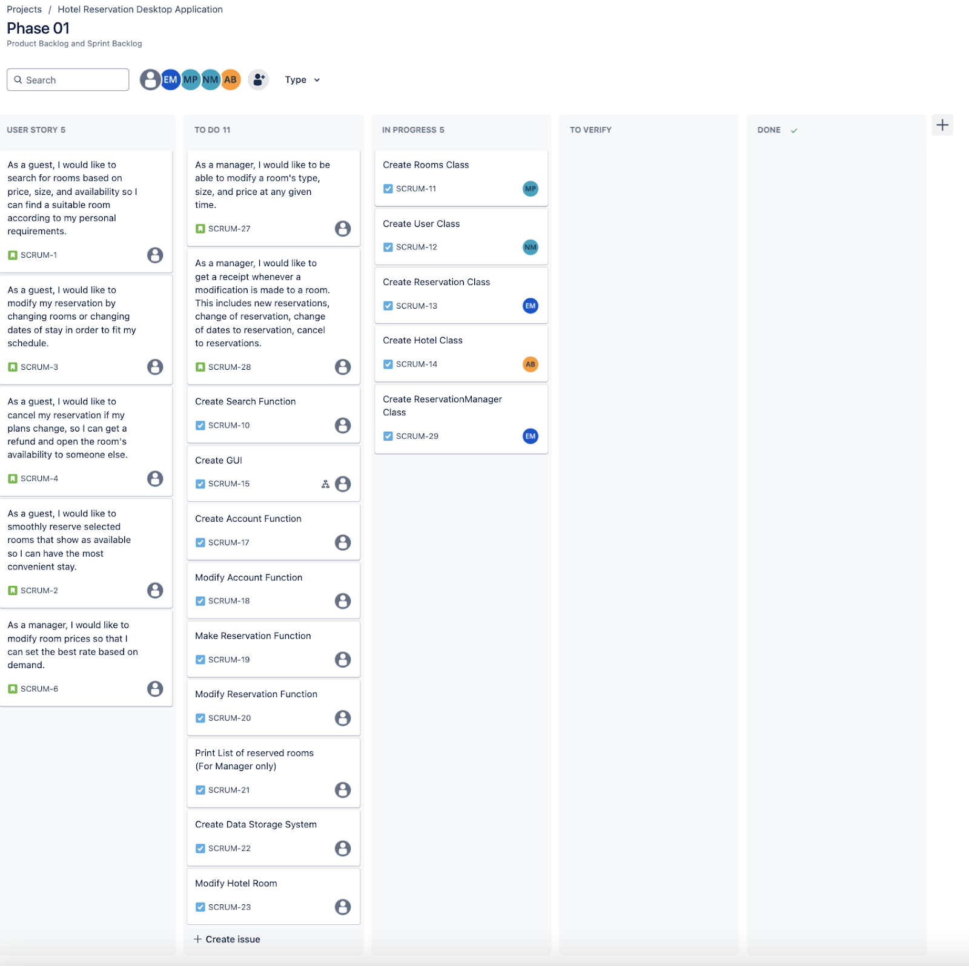

**Maintain your 2. and 3. Online using a professional project management system. Add me to your agile task board and additionally embed the link here and give me permission to view your 2. and 3.**

<https://chaotic-coders.atlassian.net/jira/software/projects/SCRUM/boards/1>

**4. Add me to your GIT repository. Embed link to your repository here.**

<https://github.com/Alexander-Boutselis/Chaotic_Coders.git>

**5. Any other comments:**

We need to spend more energy updating Jira as progress is made.